PART – 1

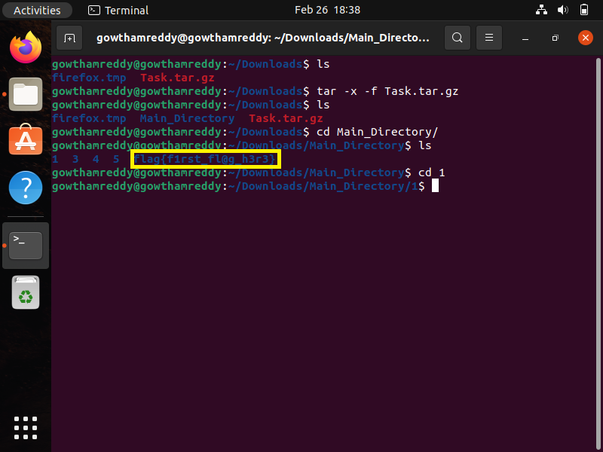1st Flag flag{first_flag_h3r3}

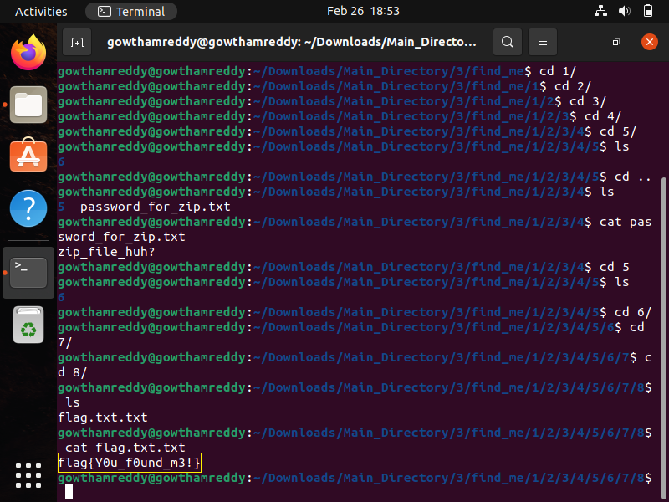2nd Flag flag{You_founnd_m3!}

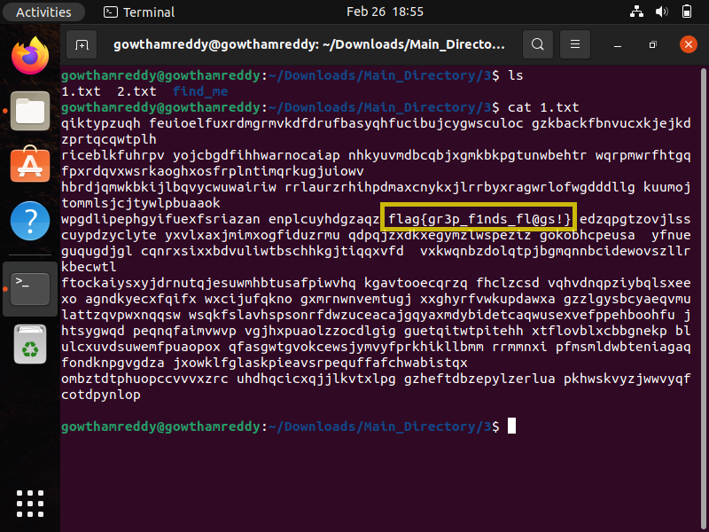3rd Flag flag{gr3p_f1nds_fl@gs!}

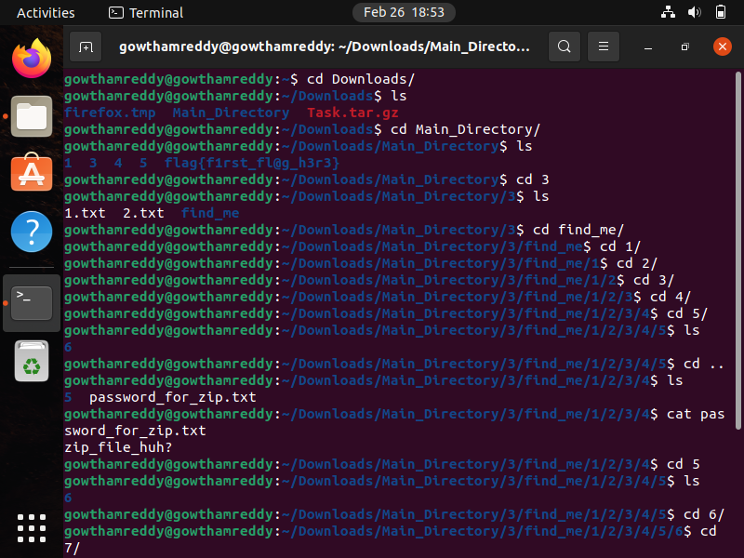4th Flag flag{e@5y_p@ssword!}

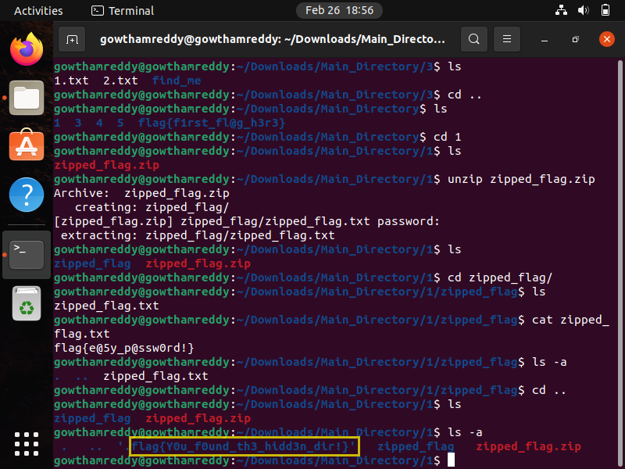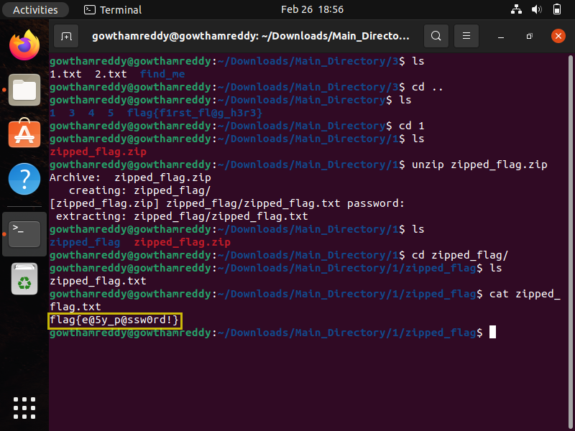5th Flag flag{You_found_th3_hidd3n_dir!}

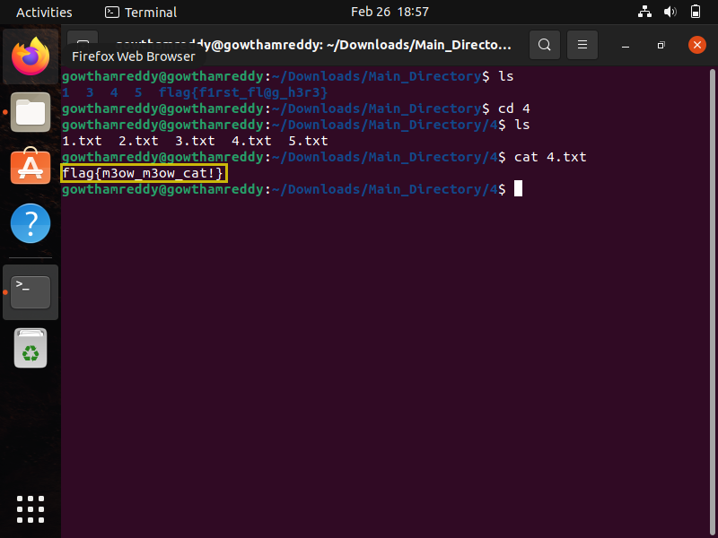6th Flag flag{m3ow_m3ow_cat!}

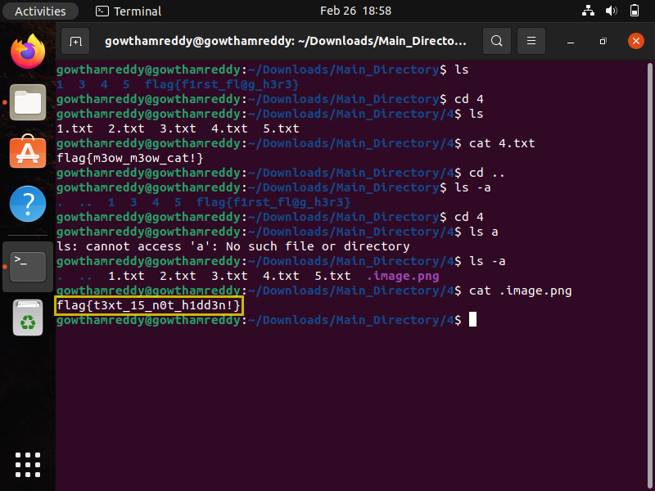7th Flag flag{t3xt_15_n0t_h1dd3n!}

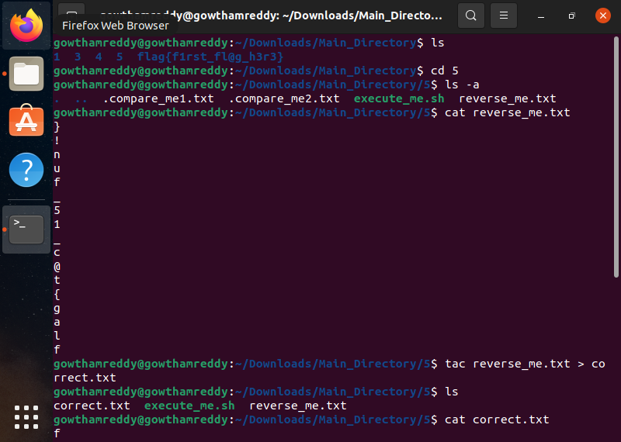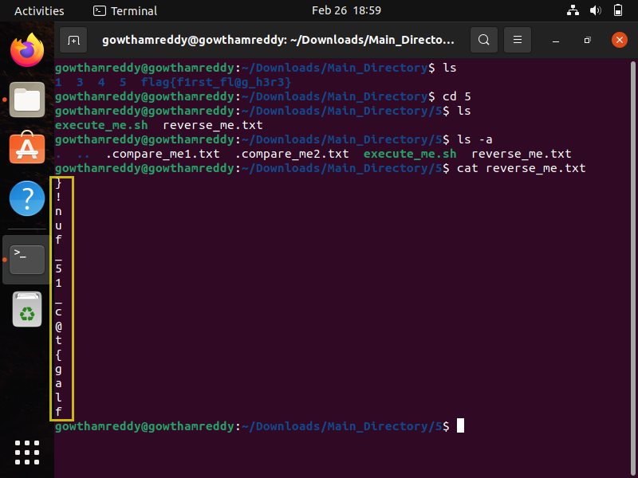8th Flag flag{t@c_15_fun!}

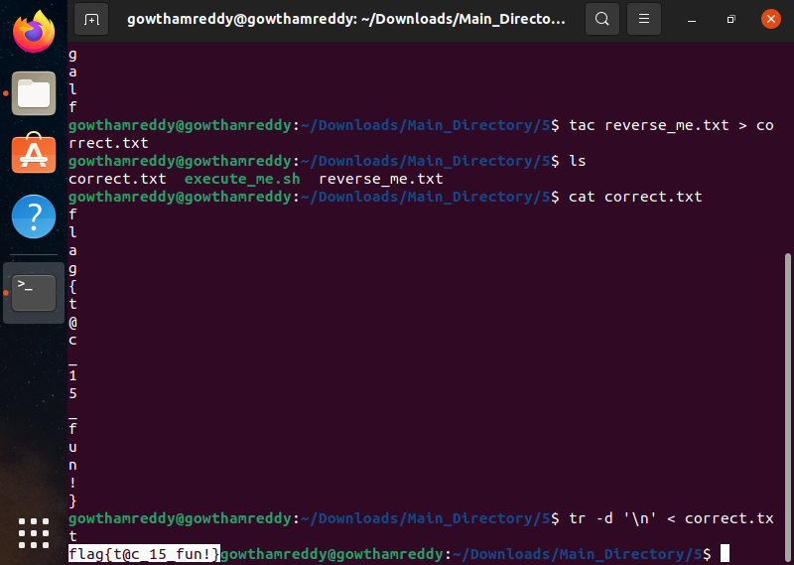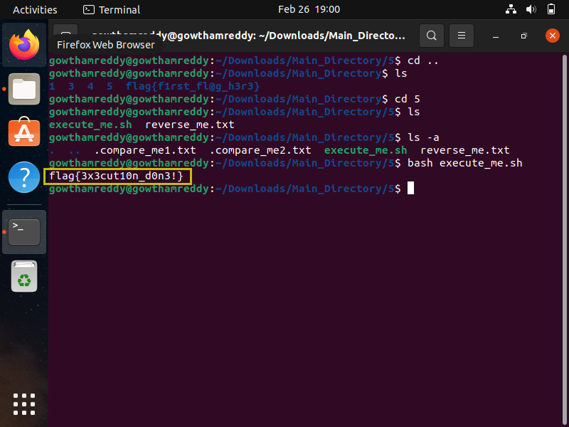

9th Flag flag{3×3cuti0n_d0n3!}

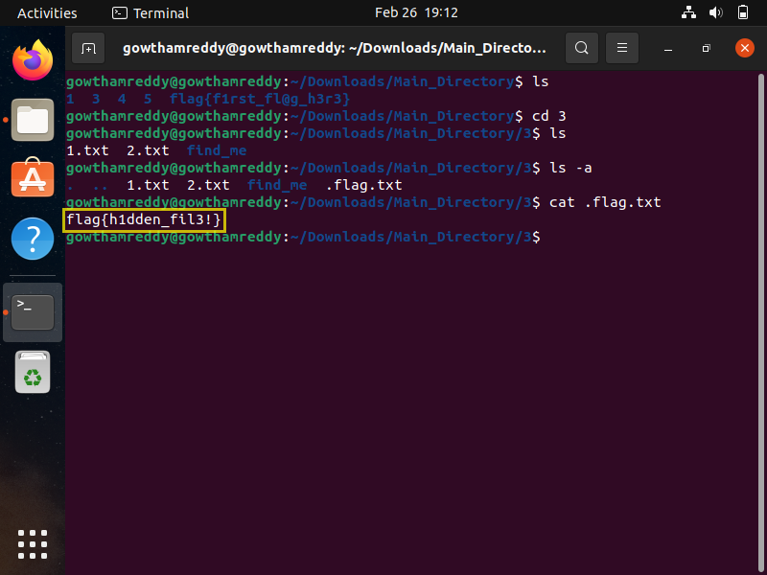10th Flag flag{h1dden_fil3!}

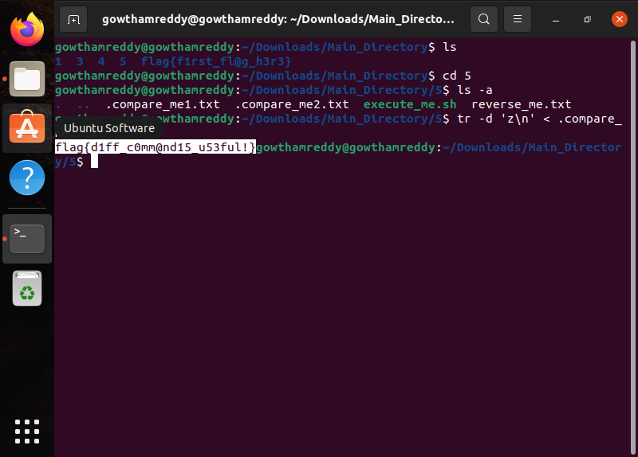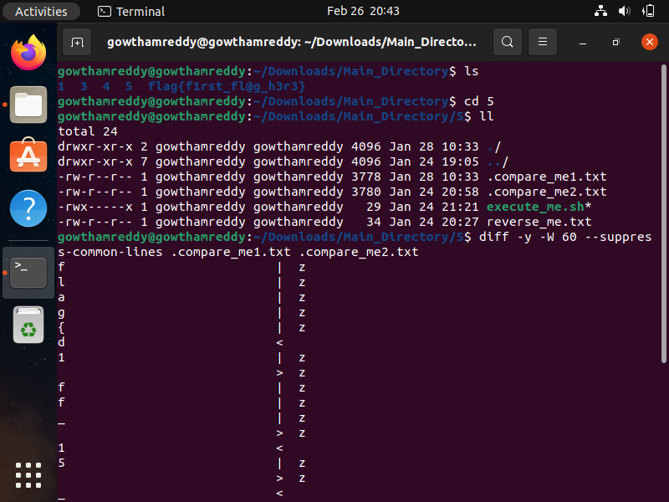11th Flag flag{d1ff _ c0mm@nd15 _u53ful!}